Management Portal Documentation

* **Overview**

The management portal is designed to manage users, roles, and system privileges across a multi-tenant environment. It consists of four primary pages:

1. SMTP Settings
2. Role Master
3. System Privileges
4. User Master

**1. SMTP Settings**

**Purpose:**

The SMTP Settings page is where smtp settings for sending emails are managed. Before creating user, this should be updated so the user can receive email when for the password when is created.

**Features:**

* Edit SMTP Settings: Modify existing Settings.

**How to Use:**

* Navigate to the SMTP Settings page.
* Enter the required fields.
* Click on the "Update" button.

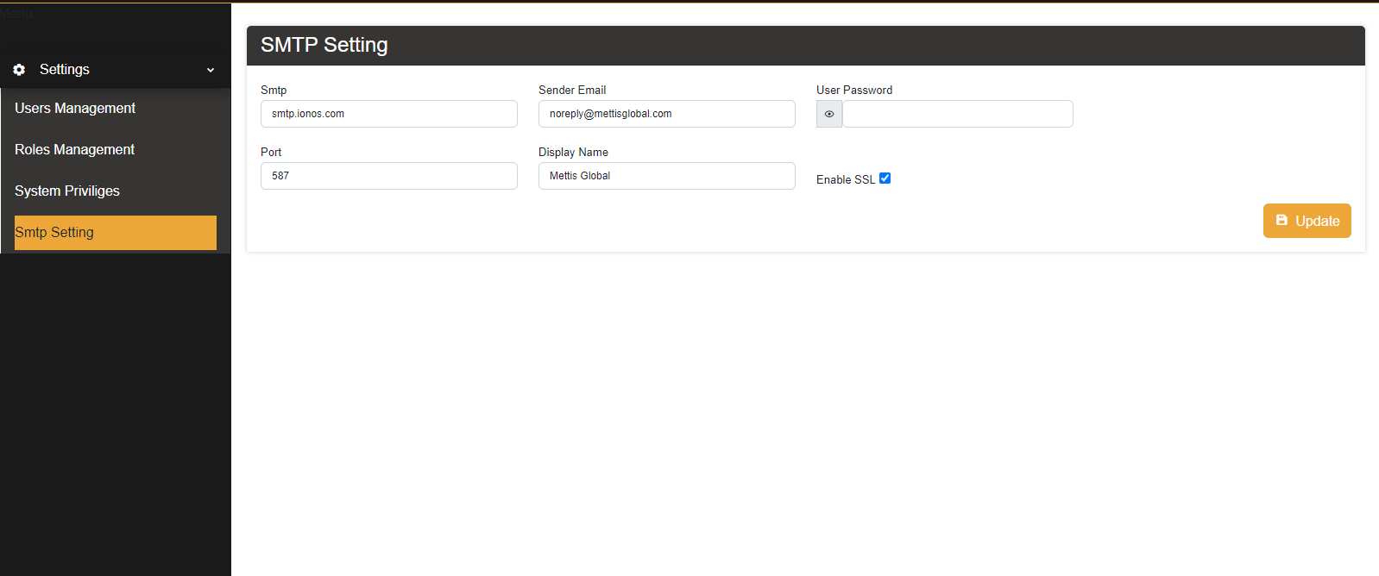

**2. Role Master**

**Purpose:**

The Role Master page is where new roles are created and managed. Roles define what pages a user visit and perform actions within the system.

**Features:**

* Create Role: Allows the creation of new roles for specific permissions.
* Edit Role: Modify existing roles.
* Delete Role: Remove roles that are no longer needed.

**How to Use:**

* Navigate to the Role Master page.
* Enter the role name and description.
* Save the role to make it available for assignment.

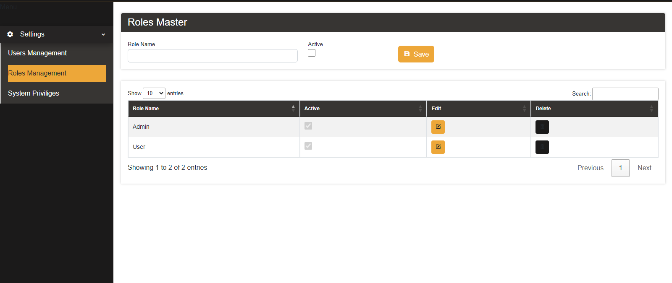

**3.** **System Privileges**

**Purpose:**

The System Privileges page allows administrators to assign specific access rights (view, insert, update, delete) to roles for each page within the system.

**Features:**

* View Privileges: Define which roles can view specific pages.
* Insert Privileges: Define which roles can add new data on specific pages.
* Update Privileges: Define which roles can modify existing data on specific pages.
* Delete Privileges: Define which roles can remove data from specific pages.

**How to Use:**

* Navigate to the System Privileges page.
* Select a role from the list.
* Check or uncheck the boxes to assign view, insert, update, and delete privileges for each page.
* Save the changes to update the role's privileges.

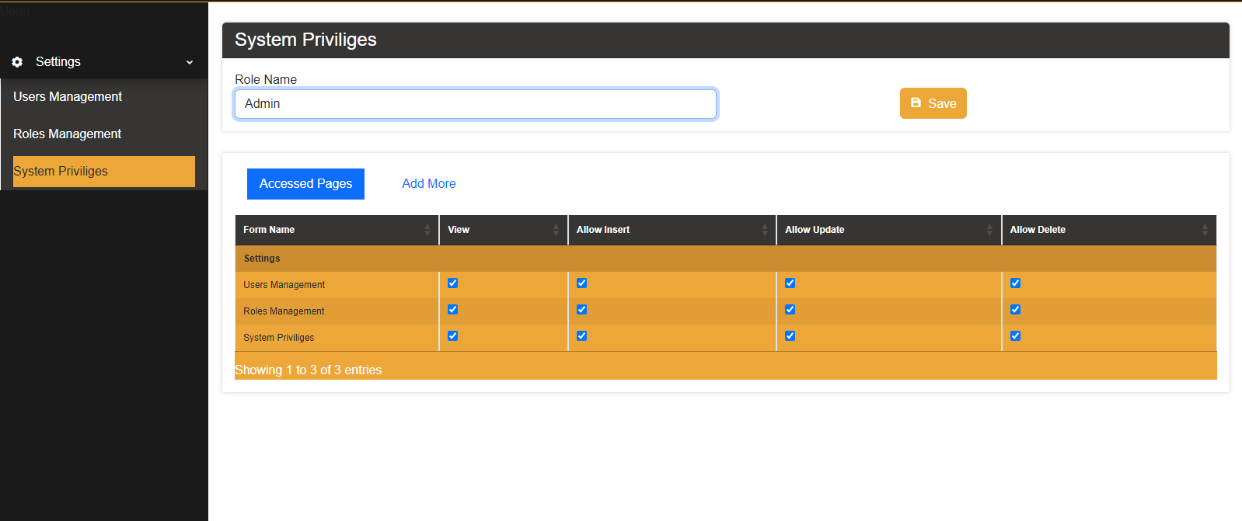

**4. User Master**

**Purpose:**

The User Master page is used for creating and managing user accounts. Users can be assigned different roles and user types (Master, Reseller, Customer).

**User Types:**

* Master: Can see and manage all their own account, reseller and customer.
* Reseller: Can see and manage their own account and customer accounts.
* Customer: Can only manage their own account.

**Features:**

* Create User: Add new users with specific roles and types.
* Edit User: Update user information and roles.
* Delete User: Remove users from the system.

**How to Use:**

* Navigate to the User Master page.
* Insert Required Fields. (Note: The password is random generated which will be emailed to the newly created user, smtp settings should be done through the smtp table in the database)
* Enter user details such as username, email, and select the user type (Master, Reseller, Customer).
* Assign a role to the user.
* Save the user to add them to the system.

